**Institution Profile**

This module will empower larger hospital and smaller clinics to have their web presence in the form of an institute profile page which would not only be informative but also serve as a landing page. The module will help to create a unique microsite and institution profile for every unique institution.

**Business Requirement:**

There are few initial business requirements is gathered, there is always a chance to improve and/or add the requirements.

**Authentication and Authorization:**

* User should be able to register as standard user or administrator of Institution.
* Admin institution can be able to add/modify/delete institution profile data.
* At the time of registration, application should validate user by otp via email or phone.

**Capturing Profile data:**

Institution administration will access profile creation page, where he/she will enter institution profile data. User should be able to modify existing data anytime.

Capture below data elements to create landing page or profile page for institution.

* + About the hospital
  + No of Beds
  + ICU Beds
  + Specialities
  + Services
  + Locations
  + Branches
  + Operational Timing
  + Pharmacy
  + Diagnostic Labs
  + Path lab
  + Trauma facility
  + Infectious disease facility – if hospital has infectious disease facility
  + Psychiatric facility – if hospital has psychiatric facility
  + Ambulance facility – If hospital has ambulance facility
  + Website address – Hospital website address
  + User Ratings – Capture user ratings, about their experiences.
  + Radiology – if hospital has Radiology department
  + Branches and their locations
  + Survey
  + Photo Gallery
  + Banner

**Ratings:**

* Microsite will present list of question to user to rate hospital services based on Quality of care, Facilities, Staff, Promptness etc.
* Application should provide facility to create institution their own questions, render priorities etc.
* Only logged user should be able to provide their ratings.
* Ratings should be presented on Institution profile page.

**Survey**

* Survey of patient’s experiences: How patients recently discharged from the hospital responded to a survey about their hospital experience. The survey will ask question like how well a hospital doctors and nurses communicated with the patient.
* Timely a& effective care: How often or quickly hospital give recommended treatments known to get the best result for people with certain common conditions and how hospital use outpatient medical imaging tests (like CT scan and MRIs)
* Payment and value of care: How payments made for patient treated at hospital compare to all hospital nationally and value of care provided by individual hospitals.

**Follow**:

Doctors can follow institution, institution can follow institution, institution can follow doctors.

**News Board:**

Institution can publish news, for now create design in way that user will enter news to publish. The new will be stored into database, same will be shown on UI.

**Diagnostic Lab:**

If institution has diagnostic lab, store its detail into database, on institution profile page lab details will be shown.

**Pharmacy:**

If institution has Pharmacy, store its detail into database, on institution profile page lab details will be shown.

**Theme**

**Template**

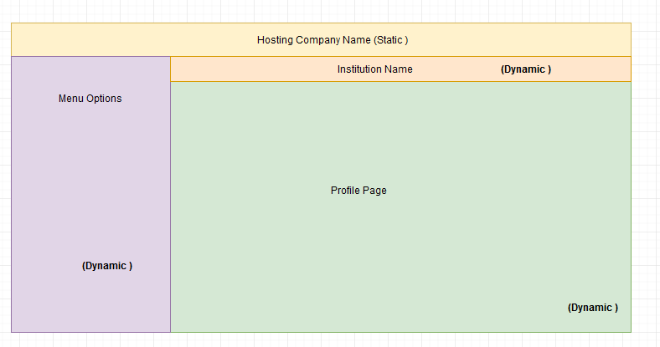

Customization:

All aspect of the page should be customizable except framework which will be fixed.

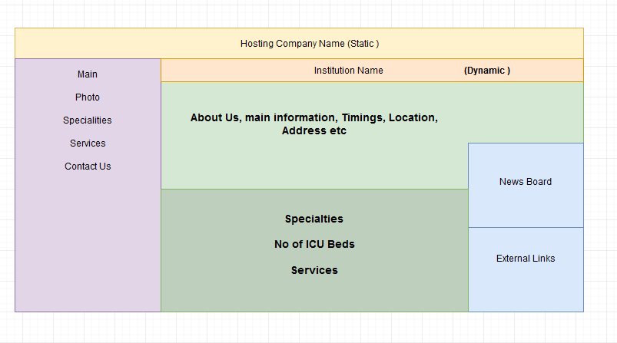

Templates:

* + The idea of templates is to make it easier for the user to design/update/customize the institution profile page.
  + There will be a few templates made available to choose form to have a particular layout or theme for the profile page.
  + The selection will be first based on layout and then on the theme.

Dynamic Nature

A lot of aspect of the site is dynamic in nature e.g:

News Board

Photos – standard jpg/png format size < 5 mb each

Limited to 20 photos.

The maintainer of the site should have full access to make the content changes. Preview them and then save them.   
 The photos should be unloadable

The photos should be viewable in an album type navigation.

Self Service Capabilities:

The sites are designed with two main concept/objectives in mind:

Customization

Self Service capabilities

